Project name: Unintended consequences of post-crisis banking reforms (PhD thesis)

- Lead researcher: Ioana Neamtu

- Data steward: Lisa Koks

- Research question(s): Chapters 2 and 3
Do CoCo bonds increase the risk appetite of banks? And
What is the impact of the leverage ratio introduction on capital allocation and bank risk taking?

- Data to be gathered (including location): A data description can be found below:
The location for data gathering is:
- Bank of England for the following data sources Eikon Thomson One, Bloomberg, SNL, Refinitive Eikon, Bank of England internal measurement, SMMD (Sterling Money Market Data)
- UvA for Yahoo Finance, Factset and Bank of England exchange rate statistics
A more detailed description can be found in the PhD thesis chapters, with a summary of data sources in Tables 3.1 and 4.2 (as shown below).
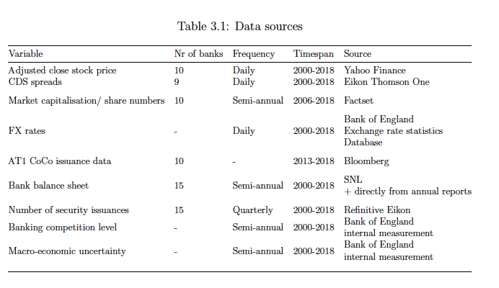
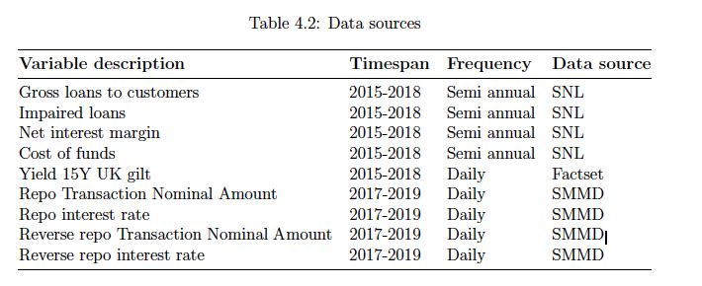

- Method of data collection (in case of personal data indicate the basis (grondslag)):
The method of data collection was collecting specific bank balance sheet data for each UK bank in our sample (15 banks) from the sources mentioned above, and also manual filling of various empty values directly from the annual reports (done by one of my co-authors). The two variables of internal measurement ( banking competition level in the UK and macro-economic uncertainty) were taken on the aggregate value computed by Bank of England staff in internal reports. The SMMD database of repo transactions is a highly sensitive regulatory dataset at which my co-author (Quynh-Anh Vo) got a one-time access after asking special permission for our research project. The data collection happened in 2018 and 2019.

Individuals involved in data gathering, data manipulation/editing and with access to the data:

For chapter 3 of the thesis the other individuals involved besides myself were: Mahmoud Fatouh and Sweder van Wijnbergen.

For chapter 4: Quynh-Anh Vo.
- Data Protection Impact Assessment
The data collected is either – public ( Yahoo Finance share prices and Bank of England exchange rates database), proprietary ( either from UvA – Factset, or Bank of England – Bloomberg, SNL, Refinitive Eikon, Eikon Thomson One) or highly sensitive/confidential (SMMD).
For all the Bank of England proprietary data I had to sign a non-disclosure agreement, and I was only allowed to use the data gathered exclusively for the two projects mentioned above. The data mainly deals with bank balance sheet information and CDS spreads.

The Sterling Money Market Data (SMMD) is a regulatory dataset from the Bank of England which has transactional level data of repo and reverse repo transactions done in the UK. This granularity of information is highly sensitive, but we only had a one-off access when we aggregated and estimated our desired parameters. In other words, the dataset is exclusively stored on a Bank of England server and we do not have easy access to it anymore.
In other words, the majority of data is not available for distribution, except for a few variables ( such as Yahoo Finance share prices and exchange rates which were further used to create some variables I use in the thesis).

Data editing/manipulation steps (e.g. SPSS Syntax files, R scripts).

The data editing was done using the following programs: Matlab, Stata and R.

We used R for estimating the desired parameters from SMMD dataset, Matlab to estimate curvatures and run the simulation analysis, and Stata to estimate our desired parameters from bank balance sheet data.

An extensive discussion of how we manipulated the data can be found in sections: 3.2 Data and empirical methodology (pages 71-85), 3.3. Descriptive statistics and empirical results (pages 86-98), section 4.5 Model calibration (136-140) and section 4.6 Numerical simulations (140-151).

All the scripts are stored on my personal computer and are available at request.

Some summaries of the aggregate results of data manipulation or raw descriptive statistics are found below ( the tables can be found in the thesis):

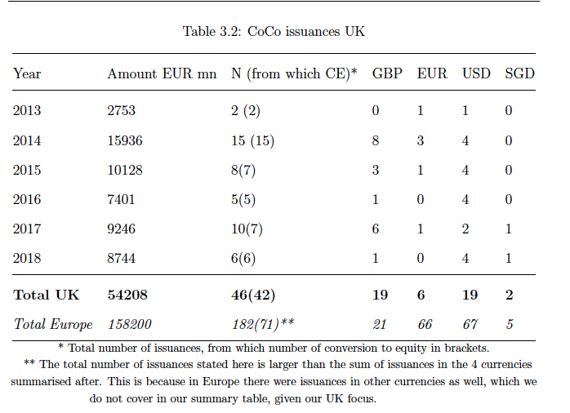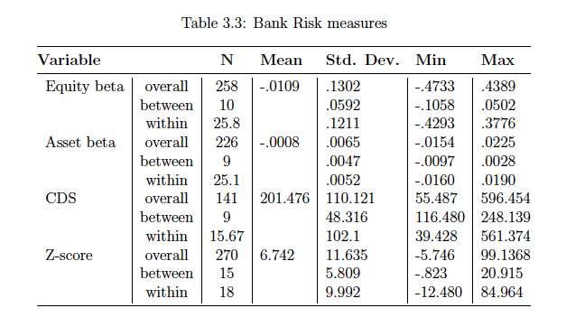
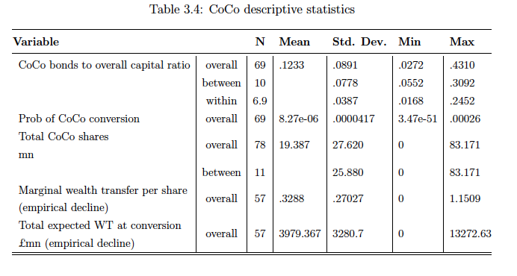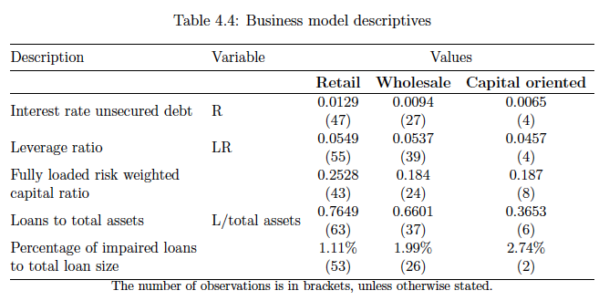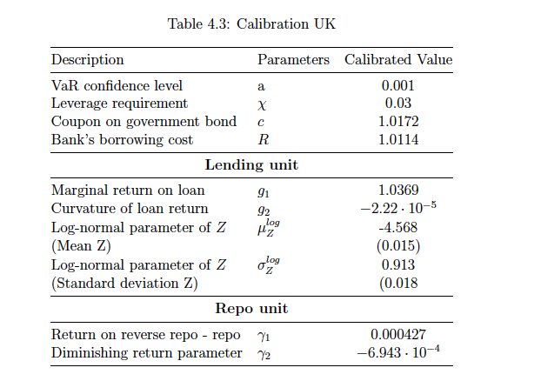
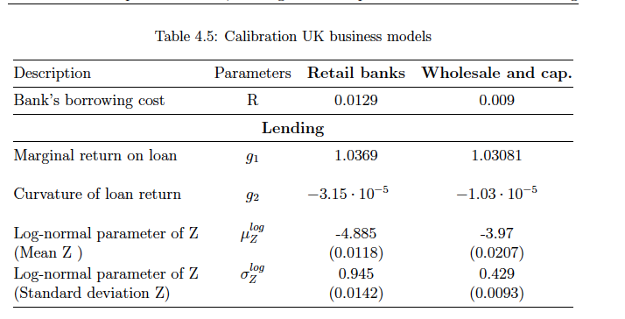

- Where and how will the data be stored (including temporary storage for research use) and security measures applied:
The proprietary and public (edited) data is stored on Bank of England computers and part of it on my personal computer, and the raw confidential dataset is on a Bank of England server we do not have immediate access to anymore (unless we make a special request).
- Approval EBEC (Economics & Business Ethics Committee) obtained: approval yes/no
- Intellectual property, copyright and ownership of the data:

The ownership of the data varies based on the source: that is either the UvA or Bank of England. The copyright of the raw data belongs to Bloomberg, Factset, Thomson One Eikon, SNL, Refinitive Eikon, and Yahoo Finance.

